**EX NO: 03 DCL COMMANDS**

**AIM:**

To work with DCL commands

**PROCEDURE:**

**Step 1**: Open Run SQL on Command line and connect to SQL

**Step 2:** Then work with database using SQL queries.

**USER CREATION:**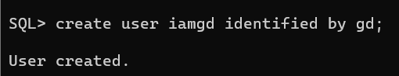

**1. GRANT:**

SQL Grant command is specifically used to provide privileges to database objects for a user. This command also allows users to grant permissions to other users too.

**Syntax:**

grant privilege_name on object_name

to {user_name | public | role_name}

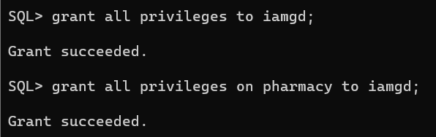**OUTPUT:**

**2. REVOKE:**

Revoke command withdraw user privileges on database objects if any granted. It does operations opposite to the Grant command. When a privilege is revoked from a particular user U, then the privileges granted to all other users by user U will be revoked.

**Syntax:**

revoke privilege_name on object_name

from {user_name | public | role_name}

**OUTPUT:**

